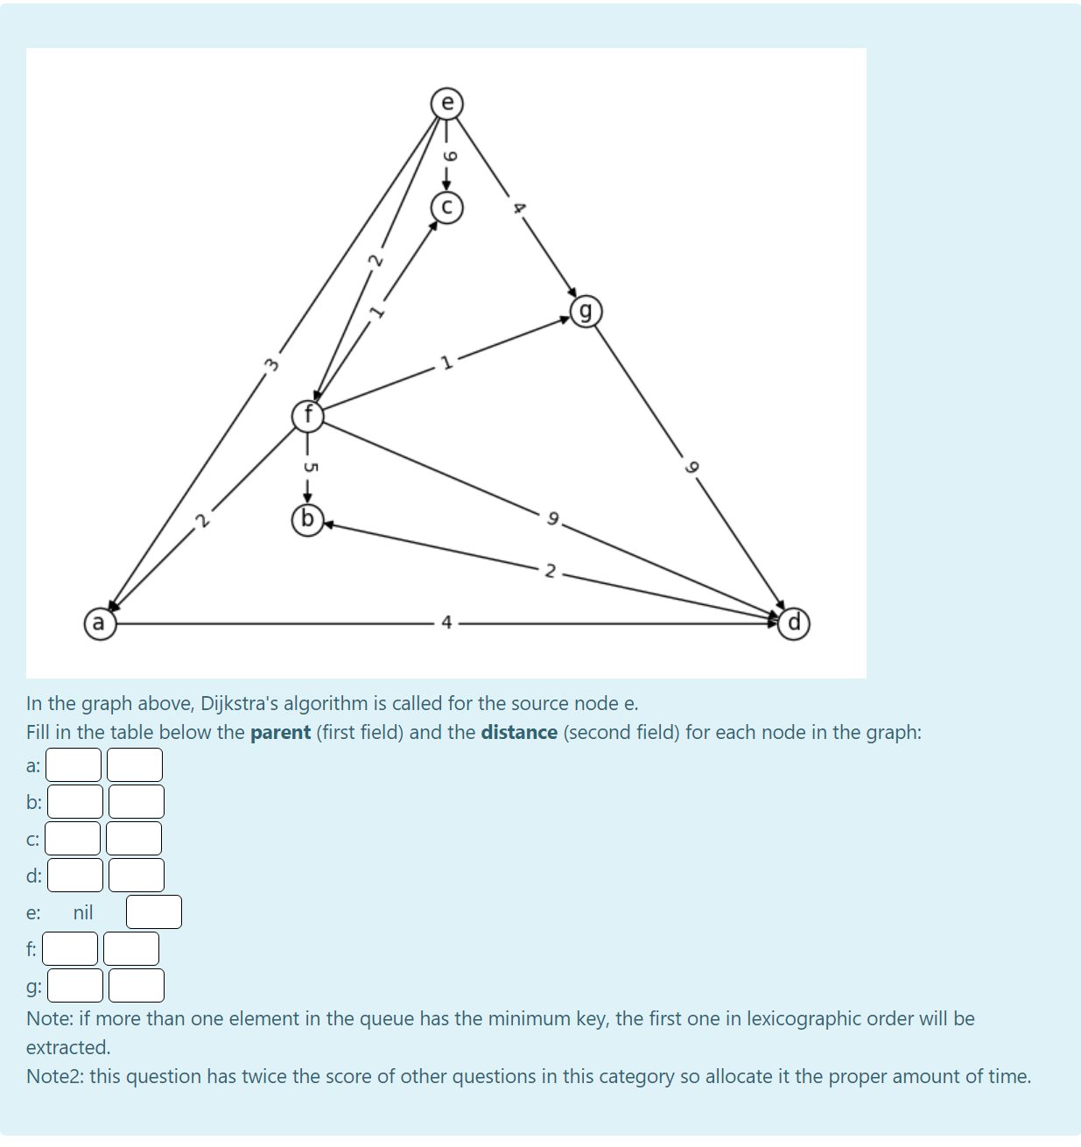
9
In the graph above, Dijkstra's algorithm is called for the source node e. Fill in the table below the parent (first field) and the distance (second field) for each node in the graph: a: b:/ c:
e:
nil
g: 1 Note: if more than one element in the queue has the minimum key, the first one in lexicographic order will be extracted. Note2: this question has twice the score of other questions in this category so allocate it the proper amount of time.

